Kashish Mittal

Northumbria University

**Depero, Fortunato (1892-1960)**

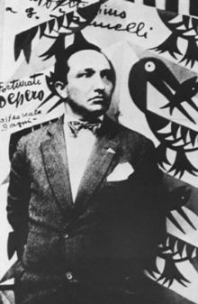

Fig. 1 Fortunato Depero

<https://it.wikipedia.org/wiki/Fortunato_Depero#/media/File:Fortunato_Depero.jpg>

Fortunato Depero was a talented artist, illustrator, stage designer and writer who played a key role in advancing the uses of typography. He was part of the Italian futurist movement, driven by passionate loathing of political and artistic traditions and was perhaps the most persistent artist of futurism, with his work embodying many of the movement’s primary inclinations. In typography, futurism broke the symmetry and tradition of the printed page by using multiple colours, typefaces, and text orientations. Depero pushed futurism beyond avant-garde circles and into the commercial sphere by applying typographic dynamism to advertising. His typographic expression was represented conceptually in his book *Depero Futurista* (1927), in advertising by his *Vogue* covers (1929, 1930), and by an iconic poster entitled *Subway* (1929). Maurizio Scudiero said in the *Italian Futurist Book* that, ‘Futurism was perhaps the first movement in the history of art to be engineered and managed like a business. It introduced the use of the manifesto as a public means to advertise its artistic philosophy, and also as a polemic weapon against the academic and conservative world.’

Depero was born on 1892, in Fondo, Italy. He was schooled at Scuola Reale Elisabettina in Rovereto, where he was taught to develop technical specialization and applied arts techniques. In 1910 Depero began working as an apprentice with a marble worker to further his artistic development. He began his approach to futurism in 1913, when he discovered the futurist paper *Lacerba*. Depero’s career had begun as a fine artist, but overtime he became the most successful futurist graphic designer. Depero was welcomed into the core of the futurist movement in 1915 by Giacomo Balla, after exhibiting a series of drawings inspired by Boccioni’s sculptures. With Balla, Depero wrote a manifesto entitled *Futurist Reconstruction of the Universe* (1915), which proposed a utopian transformation of life into a total, multi-sensory work of art. His later publication *Depero Futurista* (1927) [Fig. 2] documented his experiments in this area. The book was known for being bound with metal bolts, an appropriation of the machine aesthetic already seen in futurist painting and architecture. With its unconventional binding, the book challenged the bibliophilic cult of the library - it would damage neighbouring volumes if placed on a library shelf.

After releasing *Depero Futurista*, he moved to New York, becoming the first and only Italian futurist to move to the United States. Depero did not care for traditional rules of layout, and instead used multi-coloured text in new rather than traditional typefaces. The designs consisted of geometric shapes with a paper cutout style in black and white. The simplicity of this design reflected the idea of *The Futurist Toy*, which stated that an image should be stimulating to both children and adults alike. These designs were also easy to reproduce by line block in newspapers and in colour by lithography for posters. While in the United States, Depero designed front covers for publications such as *Vogue, Vanity Fair* and *The New Yorker.*

Depero’s magazine designs, specifically the *Vogue* covers from 1929 and 1930, are examples of how he incorporated futurist design into advertising as a means for extending the movement’s ideas [Fig. 3 and 4]. In his 1932 manifesto, *The Art of Advertising*, Depero says, ‘The art of the future will be powerfully advertising art.’ The manifesto called for advertising to reflect a new enthusiasm for ‘our glories, our men, our products.’ In 1929, Depero wrote the outline for *Il Futurismo E L’arte Pubblicitaria* (*Futurism and the Art of Advertising*), which spoke of the inevitable impact that advertising would make on art in the future. Pursuing this idea, Depero invented the concept of architettura pubblicitaria (advertising architecture). Building on Marinetti’s experiments with typography, he used bold typographic forms to create architectural structures. In his Bestetti Treves Tumminelli Book Pavilion at the Monza Biennial (1927), words became architectonic elements and the building itself became a monumental advertisement [Fig. 5].

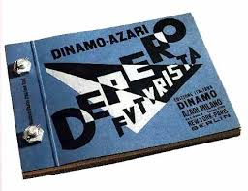

Figure 2: Depero Futurista <http://www.colophon.com/gallery/futurism/1.html>

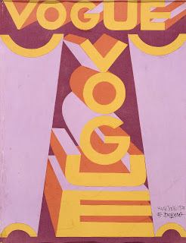

Figure 3: Fortunato Depero, *Vogue Magazine covers* 1929 and 1930. <http://designhistorymashup.blogspot.in/2008/04/fortunato-deperos-role-in-typographic.html>

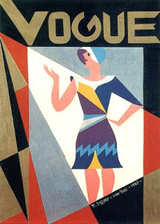

Figure 4: Fortunato Depero, *Vogue Magazine covers* 1929 and 1930. <http://designhistorymashup.blogspot.in/2008/04/fortunato-deperos-role-in-typographic.html>

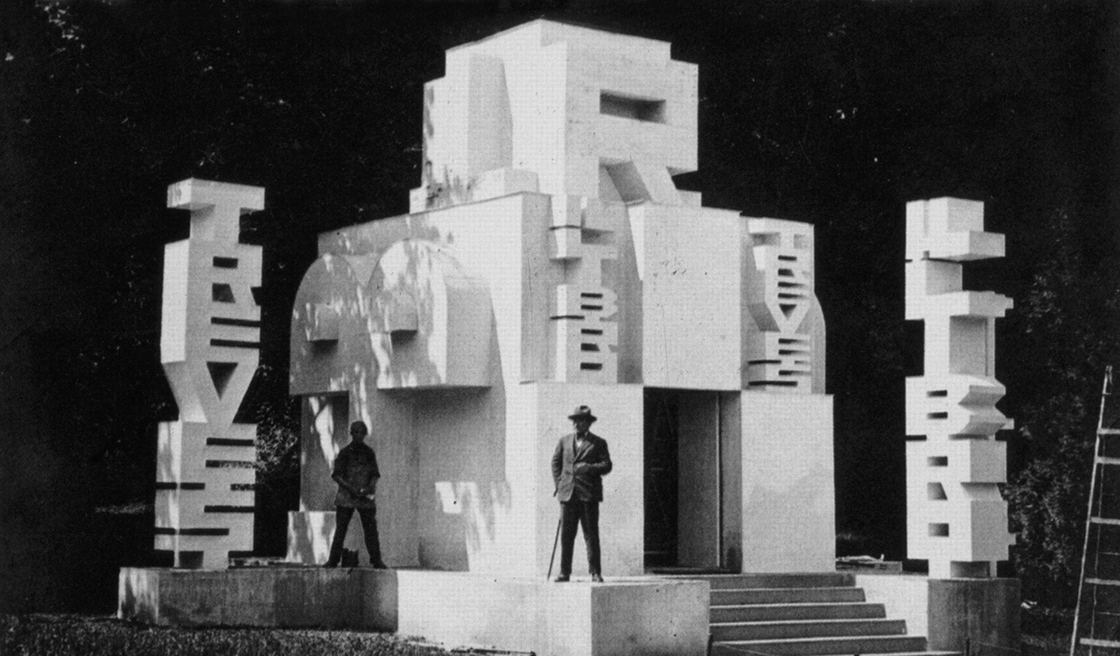

Figure 5: Depero in front of the Bestetti Treves Tumminelli Book Pavilion at the Monza Biennial (1927)

<http://jdh.oxfordjournals.org/content/21/4/335/F11.large.jpg>

Depero eventually began working on a series of advertisements for Campari aperitif, including a wood sculpture and several posters [Fig. 6]. His work was compiled into a book called *Numero Unico Futurista Campari 1931*. In addition, Depero designed a distinctive bottle for Campari Soda in 1932, which is still in production today [Fig. 7]. *Flora E Fauna Magica* (*Magical flora and fauna*) [Fig. 8] is one of the most bizarre, imaginative and surprising paintings made by Depero at the beginning of the 1920s. The dreamy atmosphere, the stylization of forms, and the distorted perspective all contribute to Depero being an avant-garde artist. In the centre of the painting is a blue elephant with two heads and three tails. The foreground has a series of fantastical flowers and shrubs, which on a closer look almost seem menacing. There is an exotic bird, a camel, and three flying fish with the fisherman with a dark complexion, in the middle who is fishing in a pool without water. The fisherman’s shadow is a strange purple and is missing the mustache and the fishing rod. Thus, Depero’s interest in antiquity permeated through several of his works and sometimes referred to many periods of art history.

Depero is an excellent example of an artist who continued to define himself as futuristic, while, in reality, introducing in his work many references to the past. His work thus becomes a complex set of elements and styles. In 1957, three years before his death, Depero constructed the *Galleria Permanente E Museo Depero* in Rovereto, Italy, a museum devoted to preserving and displaying his work and that of other futurists. Today it contains over 3000 paintings and drawings, as well as over 7500 manuscripts relevant to futurism.

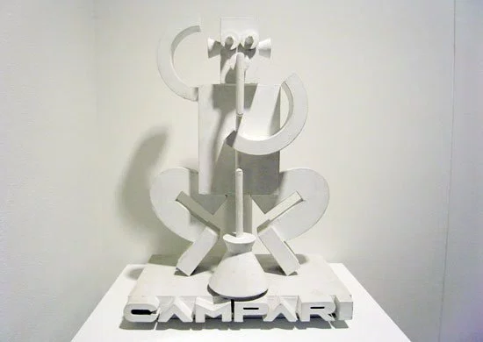

Figure 6: Fortunato Depero, Advertising wooden sculpture for Campari, 1926. <https://drehergraphicdesign.files.wordpress.com/2012/04/dep11.jpg>

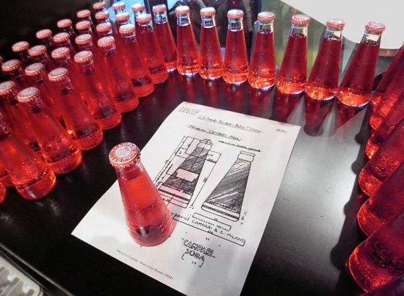

Figure 7: Fortunato Depero, Campari Soda bottles, 1932. <https://drehergraphicdesign.files.wordpress.com/2012/04/dep11.jpg>

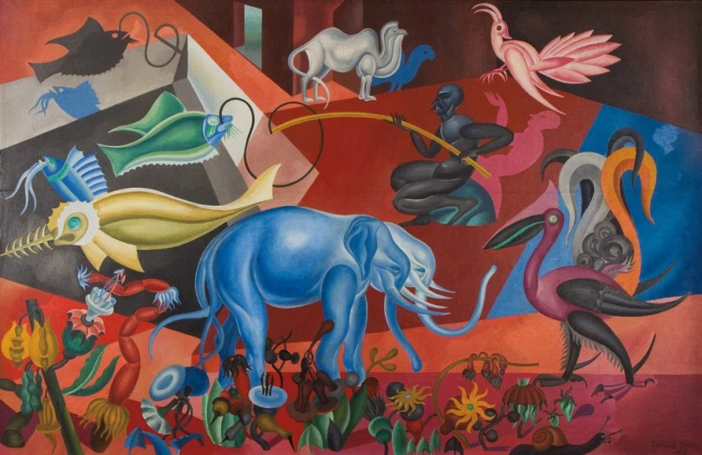

Figure 8: Fortunato Depero, *Flora E Fauna Magica*, Oil on canvas, Private collection, 1920. <http://www.italianmodernart.org/flora-e-fauna-magica-and-citta-meccanizzata-dalle-ombre-seeking-inspiration-in-the-past/depero_flora_e_fauna/>

**Further Reading:**

Chiesa, L. (2010) *Transnational Multimedia: Fortunato Depero’s Impressions of New York City*, University at Buffalo.

Cremoncini, R. (2000) *Fortunato Depero: Carnival of Colour*, Salford: Lowry Press.

# Depero, F., Scudiero, M. (2015) *Futurist Depero 1913-1950*, Fundación Juan March.

# Nason, G. (1998) *Depero Dal Futurismo Alla Casa (Italian Edition),* Edizioni Charta Srl.

Walter, A., Braun, E. (2014) *Italian Futurism, 1909-1944: Reconstructing the Universe*, Guggenheim Museum; First Edition.